

Directions: Factor the following polynomials by applying the Grouping method.

1) _____________________________

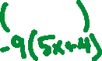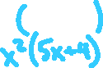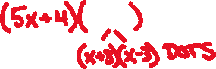

2) _______________________________

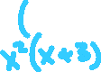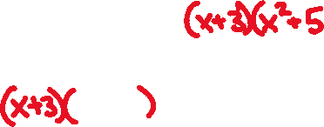

3) ________________________________

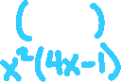

4) _______________________________

